Scala programming

Name – chaithanya gowda l

Write a Scala program to check two given integers, and return true if one of them is 30 or if their sum is 30.

INPUT:

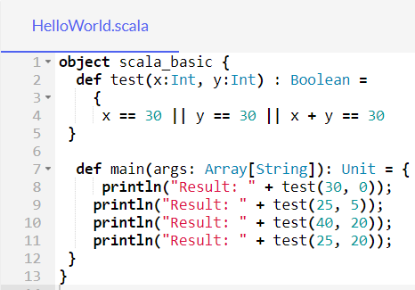

OUTPUT:

